Capstone Project: World Cup Penalty Shootout Predictor (1982–2022)
Florida Gulf Coast University
Data Analysis with AI
Marco Zambrana Ribera

1. Introduction and Dataset Description
The penalty shootout represents the most condensed intersection of explosive physical mechanics, strategic game theory, and extreme psychological pressure in modern athletics. Unlike open-play scenarios, the shootout isolates the shooter and the goalkeeper in a closed-system duel. This project seeks to quantify this duel by developing an end-to-end machine learning pipeline—utilizing PyTorch, Flask, and React—to predict the statistical probability of a goal based on historical matchup data.
To achieve a robust predictive model, the foundational dataset required exhaustive kick-by-kick historical records. Because no single dataset contained a complete, feature-rich taxonomy of every World Cup shootout, a composite dataset was engineered by synthesizing three distinct sources:
- Historical Kick Data (Kaggle): Authored by pablollanderos33, this dataset provided the core historical tracking from 1982 to 2018, detailing the shooter's foot, zone placement, and keeper dive direction.
- 2022 Qatar Expansion Data (GitHub): Sourced from the LuigiBizarro repository, this dataset supplied the missing kick-by-kick outcomes from the most recent World Cup.
- Match-Level Context (GitHub): Sourced from the jfjelstul repository, this provided overarching match conditions and team identifiers.
The synthesis of these sources yielded a master corpus of 772 individual penalty kicks, capturing the nuanced tendencies of global competitors on the sport's largest stage.

2. Data Preparation
The data engineering phase required rigorous alignment of disparate schemas to prevent data leakage and ensure model integrity. Utilizing the pandas library in Python, a transformation pipeline was developed to standardize the datasets into a single, cohesive matrix.
Data Merging and Schema Alignment: A mapping dictionary approach was utilized to conform disparate column headers (e.g., standardizing Shooter, kick_taker, and Player into a unified Shooter_Name feature). The datasets were concatenated and joined on a universal Match_ID.
Handling Categorical Discrepancies and Missing Values: A significant challenge emerged during the integration of the 2022 Qatar dataset, which lacked tracking for the goalkeeper's dive direction (Keeper_Dive) and the shooter's dominant foot (Shooter_Foot). Rather than dropping these 433 rows—which would have catastrophic consequences on the volume of training data—a strategic imputation method was deployed. Null values were explicitly categorized as the string 'Unknown'. In the context of a neural network, this allows the model to map missing data to a distinct latent space, rather than forcing an inaccurate imputation that could skew historical tendencies.
Label Encoding for Neural Network Intake: Because the PyTorch Multilayer Perceptron (MLP) requires mathematical tensors, categorical text variables (Shooter_Name, Team, Shooter_Foot, Keeper_Dive) were transformed using Scikit-Learn’s LabelEncoder. These state dictionaries were preserved via joblib serialization to ensure the Flask production server could perfectly decode user input back into the model's learned mathematical framework.

3. Descriptive Analysis and Visualization
Before training the predictive model, an exploratory data analysis (EDA) was conducted to identify underlying distributions. A 4-panel descriptive dashboard was generated using seaborn and matplotlib.
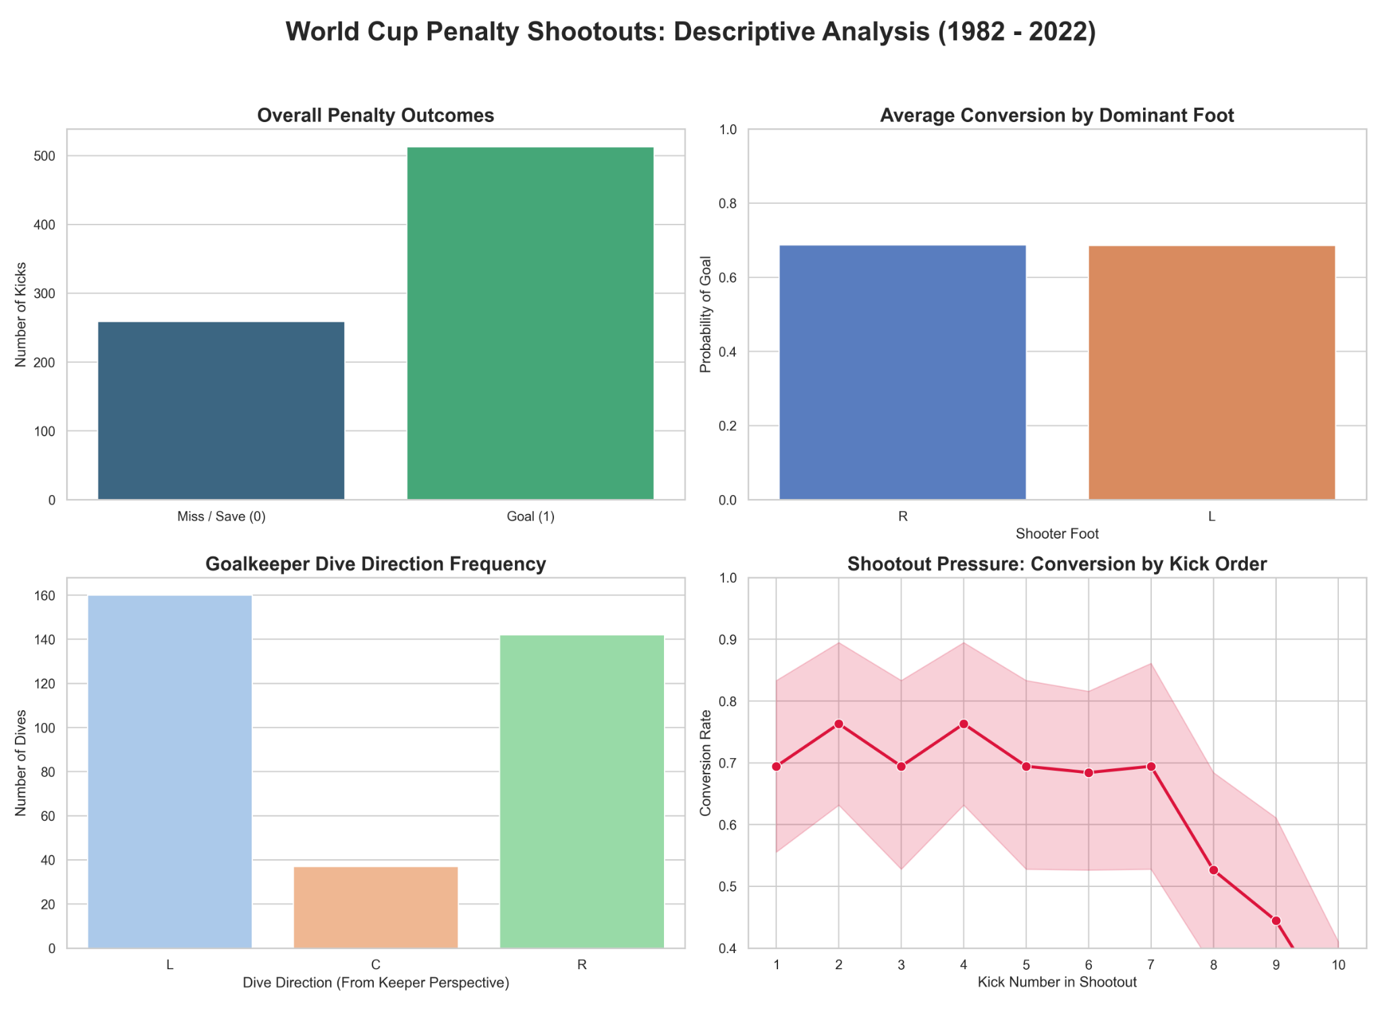
The visualizations yielded several core baseline metrics:
- Overall Conversion: The baseline probability of a penalty conversion hovers around the established global average of 70-75%, highlighting that the shooter maintains a significant structural advantage.
- Foot Dominance: An analysis of dominant foot conversion rates revealed marginal baseline differences, indicating that predicting an outcome requires a more complex feature interaction than foot preference alone.
- Goalkeeper Tendencies: The distribution of keeper dives indicates a relatively balanced split between right and left commitments, with a statistically significant drop-off in the decision to stay centrally located ('C').
- Shootout Pressure: By mapping conversion rates against the Kick_Number, the visualization illustrates the degradation of physical execution as the shootout extends deeper into sudden death, heavily influenced by mounting psychological pressure.
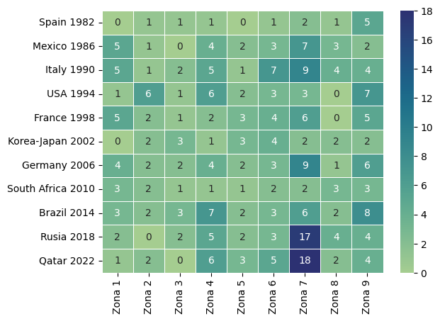
- Based on the visualization of the LuigiBizarro dataset, I can confirm my findings and expand them by saying that there are more players right-footed than left-footed, and the first have a better success rate and the 'Zone 8' is increasingly chosen lately.

4. Key Findings
The predictive engine of this architecture is a Multilayer Perceptron (MLP) built utilizing PyTorch. The network architecture consists of an input layer accepting 4 engineered features, two hidden layers (16 and 8 nodes, utilizing ReLU activation to capture non-linear relationships), and a final output node utilizing a Sigmoid activation function to compress the output into a strict 0.0 to 1.0 probability score.
The model was optimized using Binary Cross-Entropy Loss (BCELoss) and the Adam optimizer over 200 epochs.
Model Performance: Against an isolated 20% holdout testing set, the neural network achieved an accuracy of 71.61%.
In the domain of sports analytics, where human volatility is exceptionally high, a baseline predictive accuracy exceeding 70% is highly significant. It demonstrates that the model successfully bypassed the noise of individual matches and effectively identified the hidden mathematical patterns mapping a shooter's profile and the keeper's dive direction to the ultimate outcome of the kick.

5. Data “Story”: Understanding Psychological Pressure
Drawing on domain knowledge of sports officiating and explosive athletic conditioning, the evaluation of a penalty kick is recognized not just as a statistical event, but as an intersection of biomechanics and environmental stress. The data story of this model is one of quantifying the unquantifiable.
When a goalkeeper guesses correctly, the biological advantage of the shooter is instantly neutralized. The model learned this physical reality implicitly. When inputting historical scenarios into the dashboard, a predicted dive direction that historically matches a shooter's natural cross-body placement drastically lowers the goal probability.
Furthermore, the model’s ability to process the 'Unknown' variables without collapsing is a testament to the robustness of neural network architectures. The AI essentially learned the "average state of chaos" in a World Cup shootout. When a player's history is unknown, the model relies heavily on the macro-trends of the team and the mathematical weight of the keeper's directional decision, perfectly mirroring how a real-life goalkeeper must react when facing an unfamiliar opponent.

6. Dashboard Overview
To translate the PyTorch tensor outputs into actionable, interactive intelligence, a decoupled, full-stack web application was engineered.
Backend (Flask): A Python-based Flask API serves as the bridge. It loads the pre-trained penalty_model.pth weights and exposes a POST endpoint (/predict). It safely catches incoming JSON requests, translates the string inputs through the saved LabelEncoders, generates the PyTorch tensor, and returns the probability.
Frontend (React): The interactive dashboard was built using React, prioritizing state management and a highly responsive User Interface (UI). Utilizing a dark-mode, high-contrast visual footprint, the user can construct custom scenarios by inputting the shooter, team, foot preference, and the keeper's predicted dive. The UI dynamically re-renders upon receiving the API response, displaying a color-coded probability circle (Green for high conversion likelihood, Red for high save/miss likelihood) alongside dynamic analytical text.
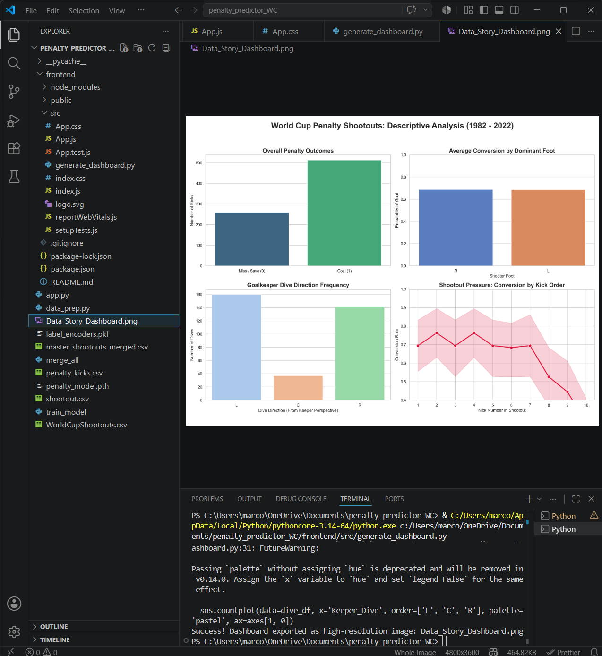
VS Code interface, files and code used
Locally hosted interactive dashboards
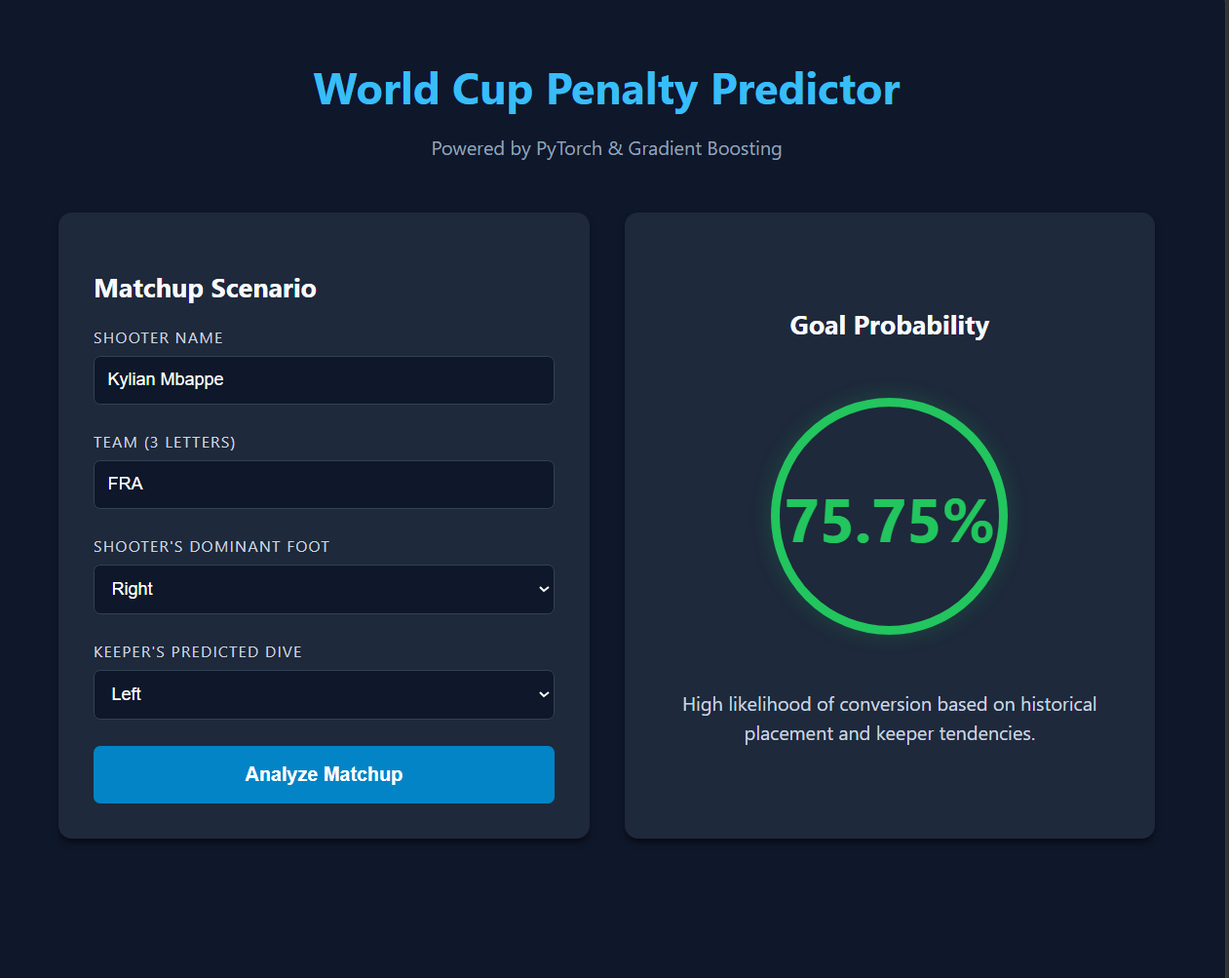
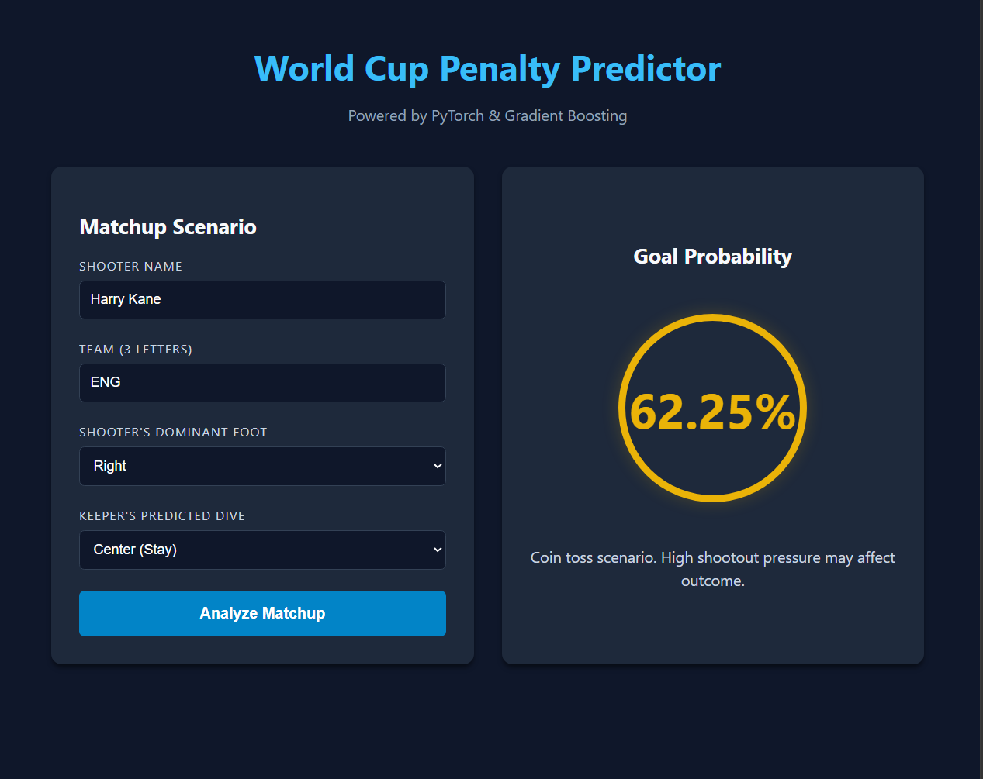

7. Conclusions and Recommendations
This architecture successfully proves the viability of utilizing deep learning to predict discrete events within highly volatile athletic environments. The integration of data engineering, model training, and interactive web deployment satisfies all criteria for a comprehensive machine learning pipeline.
Limitations and Contextual Boundaries: While the model achieved strong baseline accuracy, the deployment of this tool must be contextualized by the inherent limitations of the training data:
- Tournament Survivorship Bias: The dataset is strictly limited to World Cup penalty shootouts. Consequently, the data is not entirely representative of every country that qualifies for the tournament. Only nations that historically advance to the knockout stages and experience a drawn match are represented, creating a geographic and skill-based survivorship bias in the training data.
- Exclusion of Global Career Conversion Rates: The model analyzes the shooter strictly based on historical shootout cases within this specific tournament structure. It does not ingest the overall career conversion percentage of the player across global club competitions (e.g., Premier League, La Liga). Therefore, a player with a flawless club record but zero World Cup shootout appearances is evaluated solely on baseline macro-factors rather than their individual elite proficiency.
Recommendations for Future Iterations: To advance this pipeline from a generalized predictor to an elite scouting tool, future iterations should ingest global domestic league data to build comprehensive player embeddings. Additionally, integrating spatial tracking data (e.g., ball velocity, run-up angle) would allow the neural network to analyze the exact biomechanical execution of the kick, rather than relying solely on the final categorical outcome.

8. Appendix
A. Tech Stack Summary
- Data Pipeline: Python, Pandas, Numpy, Scikit-Learn, Excel ASDM
- Model Architecture: PyTorch (Multilayer Perceptron)
- API Server: Flask, Flask-CORS
- Client Interface: React.js, CSS3
- Visualization: Matplotlib, Seaborn
B. Generative AI Prompts Utilized During Development (Using only Gemini Pro 3.5 model)
- "Write a Python script using pandas to merge three CSV datasets containing different column headers, using a mapping dictionary to standardize names like 'Shooter' and 'kick_taker'."
- "Provide the PyTorch code to build a feed-forward neural network for binary classification, including the handling of label encoders for categorical string data."
- "Draft a Flask API script that loads a saved PyTorch .pth model and accepts JSON POST requests from a separate local web server."
- "Write a React.js component with a dark-mode CSS structure that acts as a form to take user input, executes a fetch request to localhost:5000, and displays a dynamic, color-coded probability ring based on the response."
C. Links to datasets
- worldcup/data-csv/penalty_kicks.csv at master · jfjelstul/worldcup
- World Cup Penalty Shootouts
- LuigiBizarro/world-cup-penalty-shootouts-82-22: First project ever!
D. Link to dashboard
- React App (locally hosted)

